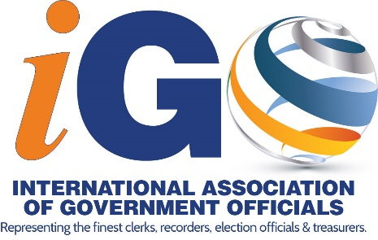
STATUS OF DELEGATION DIRECTORS – JUNE 2021
DELEGATION | NAME | EMAIL
Alabama | Alexandria Stephens | stephensa@jccal.org
Alaska | VACANT
Arizona | Tonia Tunnell | ttunnell@risc.maricopa.gov
Arkansas | Cheryl Wilson | cherylwilson86@gmail.com
California | VACANT
Colorado | Michelle Miller | mmiller@parkco.us
Connecticut | Joyce Mascena | joyce.mascena@glastonbury-ct.gov
Delaware | Lisa Darrah | Lisa.Darrah@newcastlede.gov
Florida | Tom Kennedy | tkennedy@broward.org
Georgia | VACANT
Idaho | VACANT
Hawaii | VACANT
Illinois | Lynn Fechner | irisheyes502@aol.com
Indiana | VACANT
Iowa | VACANT
Kansas | Rebecca Seeman | Rebecca.Seeman@saline.org
Kentucky | Kevin Mooney | kevin.mooney@ky.gov
Louisiana | Louis Perret | ljperret@lpclerk.com
Maine | VACANT
Maryland | Stephanie Taylor | sltaylor@harfordcountymd.gov
Massachusetts | Dennis McManus | mcmanuslaw@charter.net
Michigan | Lisa Lyons | lisa.lyons@kentcountymi.gov
Minnesota | VACANT
Mississippi | VACANT
Missouri | Nora Dietzel | ndietzel@boonecountymo.org
Montana | VACANT
Nebraska | Diane Battiato | diane.battiato@douglascounty-ne.gov
Nevada | Debbie Conway | djc@clarkcountynv.gov
New Hampshire | VACANT
New Jersey | Joanne Rajoppi | jrajoppi@ucnj.org
New Mexico | VACANT
DELEGATION | NAME | EMAIL
New York | Annette Hill | hilla@finance.nyc.gov
North Carolina | Crystal Gilliard | crystal.gilliard@unioncountync.gov
North Dakota | VACANT
Ohio | John Burke | jburke@medinaco.org
Oklahoma | VACANT
Oregon | Bill Burgess | bburgess@co.marion.or.us
Pennsylvania | Judy Enslen | jenslen@beavercountypa.gov
Rhode Island | VACANT
South Carolina | Sharon Coker | SCoker@greenvillecounty.org
South Dakota | VACANT
Tennessee | Karen Johnson | karen.johnson@nashville.gov
Texas | Michael Winn | mwinn@cco.hctx.net
Utah | Richard Maughan | rmaughan@co.davis.ut.us
Vermont | VACANT
Virginia | Tina Sinnen | tsinnen@vacourts.gov
Virgin Islands | Raymond Williams | raywilldpnr@yahoo.com
Washington | VACANT
West Virginia | VACANT
Wisconsin | VACANT
Wyoming | Julie Freese | julie.freese@fremontcountywy.gov
Alberta, Canada | Glen Resler | Glen.resler@elections.ab.ca
New Zealand | Dale Ofsoske | dale.ofsoske@electionservices.co.nz
Nigeria | John Chen | electionsolutions@gmail.com
Ontario, Canada | VACANT
Saskatchewan, Canada | Michael Boda | mboda@elections.sk.ca
Sweden | Bill Werngren | bill.werngren@cityhall.goteborg.se

