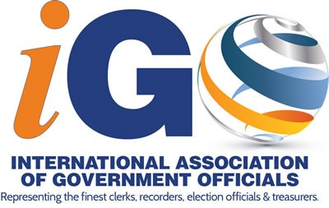

Excellence in County Government Award
Call for Nominees

The International Association of Government Officials’ (iGO) Excellence in County
Government Award was created to recognize an iGO member who exemplifies leadership,
provides excellence in his/her office and is of the highest integrity. Please nominate the
person you feel is most deserving of this award.

Guidelines and Eligibility Requirements:
•

Has exemplified leadership, ingenuity, provided excellence in his/her office and is of
the highest Integrity,

•

Has been a member of a government officials association for at least five years,

•

Has been active in attending iGO’s Annual Conferences.

Application Instructions:
•

One application must be completed for each submission.
•

All supporting documentation must be attached to the application and cannot
exceed five pages.

Send Entries to:
Mail

International Association of Government Officials
P.O.
Box 785

Dunn, NC 28335
Email

kim@iaogo.org

iGO Excellence in County Government Award Timeline:
2023
May 1, 2023

Application Deadline
June 27, 2023
Winner announced at the Awards Banquet at the iGO Annual
Conference.

For more information on the iGO Excellence in County Government Award, please visit
g
www.iaogo.or
or email

kim@iaogo.org
.
Excellence in County Government Award Nomination Form

Please use this form to nominate the person you feel most deserving of the Excellence in County Government Award. The deadline for nominations is May 1, 2023. The criteria for selection are as follows:

- Has exemplified leadership, ingenuity, provided excellence in his/her office and is of the highest Integrity
- Has been a member of a government officials association for at least five years
- Has been active in attending Winter Education Conference and Annual Conferences
- Has held a leadership role by chairing or co-chairing a committee, or has served as a member of the Board of Directors or as an officer

For the Excellence in County Government, I would like to nominate:

Name: ________________________________________________________ Title: _________________________________________
Count and State: ______________________________________________________________________
Phone: _________________________________________ Email: _________________________________________ Reason(s) for nomination (Please attach any supporting documentation you have):
Nominator: ____________________________________________________ Title: _________________________________________
County and State: ____________________________________________________________________
Phone: ____________________________________________ Email: _________________________________________
Please complete and return to:
kim@iaogo.org or by mail to P.O. Box 785 Dunn, NC 28335

